Is Hydroponically-grown food as Nutritious as soil-grown?
26.03.20 07:34 PM 4 Comment(s) By CityGreens

Like with everything else, Hydroponics has its fair mix of promoters and detractors. Many pin it down to a new fad or an unnatural way of growing, while others are incredibly upbeat, calling it the future of Agriculture. Most proponents (including us) talk about measures like reduction in the use of pesticides, optimization of resources, yield per square foot, and RoI. In today's blog, we will touch upon an equally important and pertinent topic regarding Hydroponics - Nutrition.

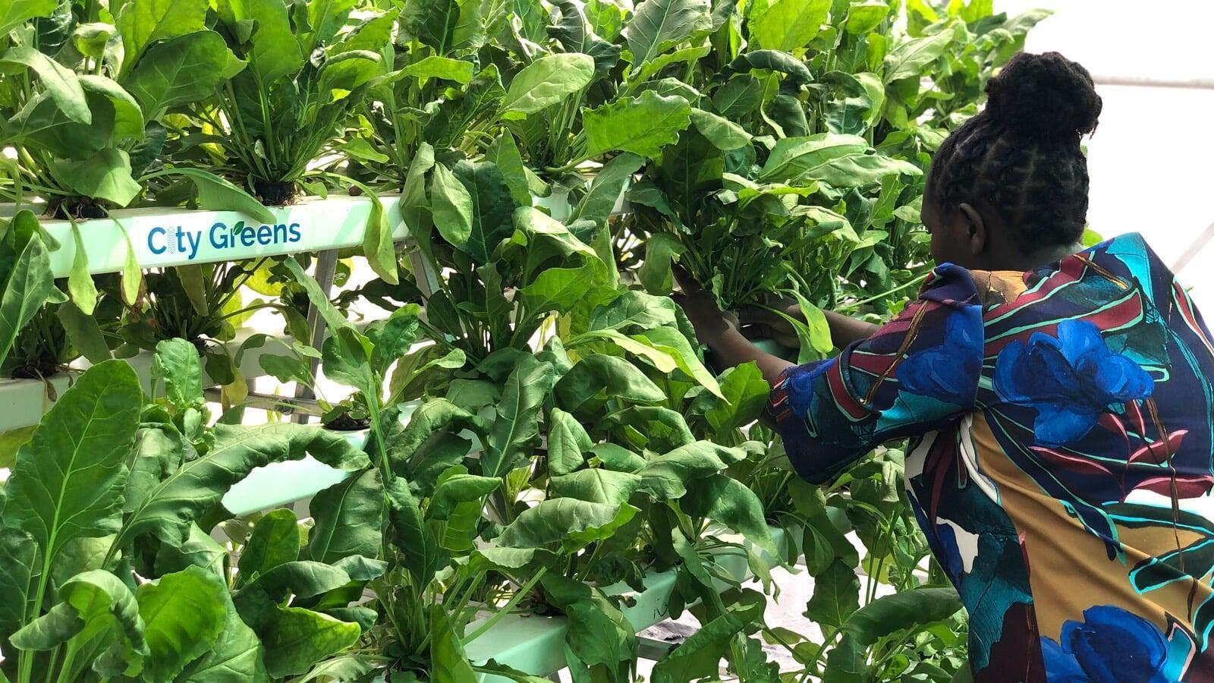

But before that, let us recap some aspects of Hydroponic growing:
- It is a scientific and calculated method of growing produce.
- It takes into account the specific requirements of each plant.
- It allows excellent control over the nutrition profile of the plant.
- It eliminates a large number of pests and thus eliminates or reduces the need for using dangerous pesticides and chemicals.

Understanding Food Nutrition

When it comes to evaluating the nutritional profile of Hydroponic produce, we should consider three critical factors, viz
- The nutrient-mix provided to the plant (nutrient given to the plant itself)
- The availability of various nutrients in the crop at the time of consumption (time from farm to table)
- Additional substances present in the food (other inputs like chemicals and pesticides used during the production phase)

Let us explore each one of these in order.

1. The nutrient mix provided to the plant

For the sake of this article, let us compare the produce grown inorganically in soil vs. the one grown in Hydroponics.

In both these cases, the primary fertilizer inputs applied to the plants are similar. They mostly differ in their form, solid vs. liquid, but the underlying compounds/minerals/elements are the same. As such, there is no significant difference in the fertilizer inputs used in soil-based growing vs. Hydroponic growing. So, logically there should be no difference in the nutritional quality of hydroponic produce vs. soil-grown produce.

Yet, subtle differences can still appear because of the following two reasons:-
  - Leaching of nutrients.
  - Soil profile.

Scope Covered
To be prudent, we will not cover the organic method of production under this head. The reason for the same is because, in the case of Organic cultivation, the input nutrient mix will vary with each batch of organic fertilizer. (Depending upon the quantity and quality of feed taken by the animals or the products that go into the compost bin, the nutritional profile of the organic manure or compost will vary from batch to batch.)

Leaching of Nutrients
Fertilizer usage in the soil does not support the principal of recirculation. An overwhelming majority of soil-based agriculture in India is dependent upon rain or uses flood irrigation methods by extracting groundwater through bore-wells. An inherent drawback of such irrigation practices is that a large amount of fertilizer seeps through the soil and get mixed into the groundwater or nearby water bodies. The pollution of natural water resources is one of the biggest banes of excessive use of fertilizers. In traditional farming methods, though a farmer can control which and how much nutrient she gives to the plant, she cannot possibly control the extent to which it remains available for the intake by the plant. The nutritional science in Hydroponics, on the other hand, works on the principle of recirculation. In Hydroponics, the nutrient-rich water is recirculated back through the plant roots repeatedly. This recirculation process helps in two ways; one, it ensures minimal wastage of nutrients. Second, the plant roots have nutrients available to them at all times. Due to this reason, a Hydroponically-grown plant should have a better nutritional profile as compared to soil-grown plants.

Of the two factors mentioned above, one promotes better nutritional profile in hydroponic vegetables while the other promotes better nutrition profile in the soil-grown plants. In the real world scenario, it will be challenging to ascertain which factor will play out how and to what extent and hence we should look at the average case scenario for our understanding. In an average case scenario, the hydroponically grown produce will have a slightly better nutrition profile overall as compared to the soil-grown produce. The same has been verified time and again by different farmers and experts from agri-industries who grow medicinal and aromatic plants. When they grow these plants using Hydroponics, the concentration of active ingredient/oil content is much higher as compared to soil-grown plants. The same should hold for nutrients.

Yet, amongst the scores of nutrients, a few specific nutrients may be in higher quantities in soil-grown produce and vice-versa. Also, this will vary from batch to batch depending upon the location/soil quality, in which the crop grew. Thus you will find multiple reports and articles in the public domain claiming both the superiority of hydroponic produce, as well as of the soil-grown produce, depending upon the source of the report and the specific nutrient element being discussed in the report.

For example, consider the following two news headlines:

Hydroponically grown Spinach has 10% more iron content than the soil-grown one. A reason to switch to safe and healthy Hydroponic produce.

Laboratory tests show that Hydroponically grown Spinach has up to 5% less Calcium than the one grown in soil. Beware of what you eat.

You may be surprised to know that both of the above headlines may use the same laboratory test report as their base. Depending upon the objective and motive of the author, she may choose to publish limited facts or data to influence a specific view-point. (Well, that's true for almost all the stats you read anywhere.)

2. Post-harvest nutrient loss in the plant

The moment a plant is harvested, it begins to lose nutrients. Higher the temperature more is the loss. What that means for you as a consumer is that if your food is grown in far off places and takes a long time transiting through the supply chain, it will have little nutrients left by the time you consume it. So, to get the same amount of nutrients as you expect you are getting from eating a single bowl of Spinach, you may as well need to eat two.

The point we are trying to drive home here is that though it is vital to ascertain how much nutrition is present in the food initially at the time of harvest, it is equally, if not more, important to track the time lag from farm to fork, or how fast you get your food post-harvest.

By that metric alone, Hydroponics is a clear winner (unless, of course, you grow your food) as most of the hydroponic farms are setup within or near large cities and provide their produce fresh to the consumer. For example, from harvesting to delivering the greens from CityGreen's indoor farm in Bangalore, we often manage a turnaround time of fewer than three hours. It cannot get fresh than that.

Why Fresh Matters?
How much nutrition does a food pack is only a part of the equation. Another equally critical aspect is how much of this nutrient is still present in the food when you consume it.
Need proof?
According to a Pennsylvania State University research report, Spinach loses 47% of folates and 56% of carotenoids in just four days when stored at 20° C. You can download the report from here.

3. Additional substances present in the food

We strongly believe that the third aspect that we are going to cover now is the most significant advantage offered by Hydroponics. It is common knowledge that most of the harmful pests affecting plants are soil-based. Since Hydroponics eliminates soil, it also removes all soil-borne parasites without using a single drop of pesticide. Also, since the water used for hydroponic cultivation is pre-treated and purified, even water quality is pristine. The only thing a Hydroponic grower may still need to deal with is air-borne pests (and in an entirely indoor vertical farm, even air-borne pests may not be a nuisance). As such, even if a hydroponic producer has to use pesticides, he may need to use them in much lesser quantity than a soil-based grower. This advantage exists due to the inherent nature of the technology.

Pesticide Footprint
When it comes to pesticide use, it is safe to say that Hydroponics may even be better than Organic. Contrary to popular belief, organic production does allow for pesticide use, and there is a perfectly logical reason for why it is permitted. For those interested in reading more about it, refer to this article.

The Importance of Hydroponic Produce in Cities in India

In an ideal world, Hydroponic produce will be slightly better than the soil-grown produce in terms of nutritional value and quality. But we do not live in a perfect world, and that makes Hydroponic produce far better than the soil-grown produce that we get in our neighborhood stores, especially in the big cities in India. Let me explain why.

While nutrition is a tough call, the benefit of Hydroponics is clear in terms of reducing the toxic stuff we put into our bodies. Studies indicate, that especially in the cities, the soil growing conditions of crops like Spinach is deplorable and many times the water sources used are dirty and unhygienic. For example, this news report by BBC explains how Spinach is cultivated in Bangalore using polluted water from lakes. Mumbai is not far behind. The greens you consume are often grown by the side of railway tracks and are highly toxic as per this ToI news report. If you think you are safe in Delhi, or Pune, or any other cities, think again. Twenty minutes of targeted search on internet will open your eyes and make you appreciate why we switched over to Hydroponics.

Snippets from BBC Report.

What shocked us was the candid admission of how greens are being grown using polluted water and then being sold in the vegetable markets from where it finds its way to the retail stores and ultimately to your food table.

If people know where we grow our produce, they will not buy it. So we have no other choice but to lie.

Spinach is the only crop we can grow using the polluted lake water. Other plants rot faster with polluted water.

This is not all. Even if the farmers are using borewell water to irrigate their fields, it may still not be safe. In many parts of India, the water table is contaminated. So, along with the nutrients, there are also traces of unwanted elements that may enter the system, causing disease and damage.

Now let us consider the case of pesticides. Pesticides, as such, may not be harmful if used in the right quantities and at the correct times, so that the amount of residue left at the time of harvest is negligible. But does that happen in the real world?

Why does a farmer use Pesticide?
For a farmer who has already invested substantially in terms of the seeds, fertilizers, effort, and time. Once faced with a pest, will she choose to be moderate or aggressive in saving her livelihood?

Unfortunately, this affects the human system as we consume all these unwanted pesticides causing long term health disasters. Further, incessant use of these pesticides also impacts the water tables and creates more resistant strains of pests. More often than not, society focuses on curative and is more comfortable spending on medicines and doctors rather than on preventive measures such as choosing to eat healthy and safe food even if it comes at a little premium.

Just to put things in perspective, below listed are certain findings from this report available in the public domain:
- Brinjal: Chemical found is Heptachlor, 860% above the legal limit
- Cabbage: Chemical found is Cypermethrin, 95.5% above the legal limit
- Okra: Chemical found is Heptachlor, 55% above the legal limit
- Rice: Chemical found is Chlorfenvinfos, 1324% above the legal limit
- Banana: Chemical found is Chlorodane, 54% above the legal limit
- Cauliflower: Chemical found is Aldrin, 320% above the legal limit
- Apple: Chemical found is Dichlorvas, 140% above the legal limit

Thus, it is only in the larger benefit of our health that it is advisable to grow in a medium that helps to eliminate or at least minimize the use of harmful elements that cause long term damage. India faces a daunting task of purifying and making soil worthy of growing produce as it has been infested with heavy dosages of pesticides and fungicides. As such given a choice between soil-grown and Hydroponically grown vegetables, I will always choose the ones grown hydroponically. What about you?
Happy Growing!

